

**DEVOPS AND UNIT-TESTING**

**INTERNSHIP REPORT**

**Quarter IV (Year 1)**

***Submitted by***

**Udhayan B E0420005**

***In partial fulfilment for the award of the degree of***

**BACHELOR OF TECHNOLOGY**

**in**

**COMPUTER SCIENCE AND ENGINEERING**

**(Cyber Security & Internet of Things)**

**Sri Ramachandra Engineering and Technology**

**Sri Ramachandra Institute of Higher Education and Research, Porur, Chennai -600116**

**JULY, 2020**



**DEVOPS AND UNIT-TESTING**

**INTERNSHIP REPORT**

**Quarter IV (Year 1)**

***Submitted by***

**Udhayan B E0420005**

***In partial fulfilment for the award of the degree of***

**BACHELOR OF TECHNOLOGY**

**in**

**COMPUTER SCIENCE AND ENGINEERING**

**(Cyber Security & Internet Of Things)**

**Sri Ramachandra Engineering and Technology**

**Sri Ramachandra Institute of Higher Education and Research, Porur, Chennai -600116**

**JULY, 2020**



**BONAFIDE CERTIFICATE**

Certified that this project report **“Devops and Unit-Testing”** is the bonafide work of **Udhayan B Reg No. E0420005** who carried out the internship work under my supervision.

**Signature of Faculty Mentor Signature of Vice-Principal**

|  |  |
| --- | --- |
| **Chiranjeevi N**  Assistant Professor  Sri Ramachandra Engineering and Technology  Porur  Chennai-600116 | **Prof. M. Prema**  Vice-Principal  Sri Ramachandra Engineering and Technology  Porur  Chennai-600116 |

**Evaluation Date:**

**Table of Contents**

**Title** **Page**

1. Domain Introduction 6

Data Analytics 6

1. Objective 7
2. Technology Used 8
   1. TensorFlow 8
   2. Open CV 8
   3. Mediapipe 8
   4. SK learn 9
   5. Matplotlib 9
   6. Jupyter notebook 9
3. Sample Output 10
4. Code 10
   1. Import and install dependencies 10
   2. Key points using MP holistic 10
   3. Extract key points 13
   4. Setup folders for collection 14
   5. Testing and training 15
   6. Pre-process Data and Create Labels and Features 17
   7. Build and Train LSTM Neural Network 17
   8. Save Model 18
   9. Test in Real Time 18

6. Output 21

7. Conclusion 22

8. References 22

**ACKNOWLEDGEMENT**

I express my sincere gratitude to our Chancellor, Vice-Chancellor and our sincere gratitude to our Provost **Dr. Raju** and our Vice-Principal **Prof. Prema** for their support and for providing the required facilities for carrying out this study.

I wish to thank my faculty mentor, **Prof. Chiranjeevi N,** Department of Computer Science and Engineering, Sri Ramachandra Engineering and Technology for extending help and encouragement throughout the project. Without his/her continuous guidance and persistent help, this project would not have been a success for me.

I am grateful to Department of Computer Science and Engineering, Sri Ramachandra Engineering and Technology, our beloved parents and friends for extending the support, who helped us to overcome obstacles in the study.

**1.DOMAIN INTRODUCTION**

**Data Analytics:**

Analytics is the systematic computational analysis of data or statistics. It is used for the discovery, interpretation, and communication of meaningful patterns in data. It also entails applying data patterns towards effective decision-making. It can be valuable in areas rich with recorded information; analytics relies on the simultaneous application of statistics, computer programming and operations research to quantify performance.

Organizations may apply analytics to business data to describe, predict, and improve business performance. Specifically, areas within analytics include predictive analytics, prescriptive analytics, enterprise decision management, descriptive analytics, cognitive analytics, Big Data Analytics, retail analytics, supply chain analytics, store assortment and stock-keeping unit optimization, marketing optimization and marketing mix modelling, web analytics, call analytics, speech analytics, sales force sizing and optimization, price and promotion modelling, predictive science, graph analytics, credit risk analysis, and fraud analytics. Since analytics can require extensive computation (see big data), the algorithms and software used for analytics harness the most current methods in computer science, statistics, and mathematics

**2.Objective:**

Sign language is one of the oldest and most natural form of language for  
communication, but since most people do not know sign language and  
interpreters are very difficult to come by we have come up with a real time  
method using neural networks for fingerspelling based american sign  
language. Our method provides 90.5% accuracy for the 26  
letters of the alphabet.

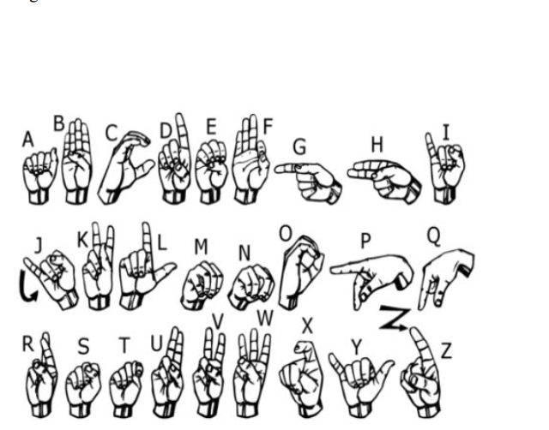

**3. Technology used:**

**3.1 TensorFlow:**

****TensorFlow is a free and open-source software library for machine learning. It can be used across a range of tasks but has a particular focus on training and inference of deep neural networks. TensorFlow is a symbolic math library based on dataflow and differentiable programming.

**3.2 OpenCV**:

OpenCV is a library of programming functions mainly aimed at real-time computer vision. Originally developed by Intel, it was later supported by Willow Garage then Itrez. The library is cross-platform and free for use under the open-source Apache 2 License.

**3.3 Mediapipe:**

 **Mediapipe** is a cross-platform framework for building multimodal applied machine learning pipelines. ... video, audio, any time series data), cross platform (i.e. Android, iOS, web, edge devices) applied ML pipelines.

**3.4 SKLearn:**

 Scikit-learn is a free software machine learning library for the Python programming language. It features various classification, regression and clustering algorithms including support vector machines,

**3.5 Matplotlin:**

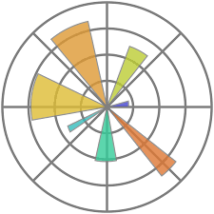Matplotlib is a plotting library for the Python programming language and its numerical mathematics extension NumPy. It provides an object-oriented API for embedding plots into applications using general-purpose GUI toolkits like Tkinter, wxPython, Qt, or GTK.

**3.6 Jupyter Notebook:**

****Project Jupyter is a project and community whose goal is to "develop open-source software, open-standards, and services for interactive computing across dozens of programming languages". It was spun off from I Python in 2014 by Fernando Pérez.

**4.Sample Output:**

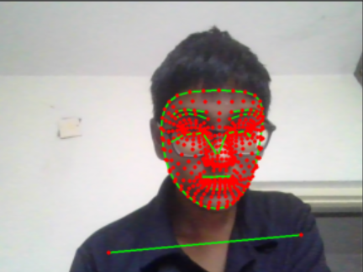

**5 Code:**

# 1. Import and Install Dependencies

**!**pip install tensorflow**==**2.4.1 tensorflow**-**gpu**==**2.4.1 opencv**-**python mediapipe sklearn matplotlib

import cv2

import numpy as np

import os

from matplotlib import pyplot as plt

import time

import mediapipe as mp

# 2. Key points using MP Holistic

mp_holistic = mp.solutions.holistic # Holistic model

mp_drawing = mp.solutions.drawing_utils # Drawing utilities

def mediapipe_detection(image, model):

image = cv2.cvtColor(image, cv2.COLOR_BGR2RGB) # COLOR CONVERSION BGR 2 RGB

image.flags.writeable = False # Image is no longer writeable

results = model.process(image) # Make prediction

image.flags.writeable = True # Image is now writeable

image = cv2.cvtColor(image, cv2.COLOR_RGB2BGR) # COLOR COVERSION RGB 2 BGR

return image, results

def draw_landmarks(image, results):

mp_drawing.draw_landmarks(image, results.face_landmarks, mp_holistic.FACE_CONNECTIONS) # Draw face connections

mp_drawing.draw_landmarks(image, results.pose_landmarks, mp_holistic.POSE_CONNECTIONS) # Draw pose connections

mp_drawing.draw_landmarks(image, results.left_hand_landmarks, mp_holistic.HAND_CONNECTIONS) # Draw left hand connections

mp_drawing.draw_landmarks(image, results.right_hand_landmarks, mp_holistic.HAND_CONNECTIONS) # Draw right hand connections

def draw_styled_landmarks(image, results):

# Draw face connections

mp_drawing.draw_landmarks(image, results.face_landmarks, mp_holistic.FACE_CONNECTIONS,

mp_drawing.DrawingSpec(color=(80,110,10), thickness=1, circle_radius=1),

mp_drawing.DrawingSpec(color=(80,256,121), thickness=1, circle_radius=1)

)

# Draw pose connections

mp_drawing.draw_landmarks(image, results.pose_landmarks, mp_holistic.POSE_CONNECTIONS,

mp_drawing.DrawingSpec(color=(80,22,10), thickness=2, circle_radius=4),

mp_drawing.DrawingSpec(color=(80,44,121), thickness=2, circle_radius=2)

)

# Draw left hand connections

mp_drawing.draw_landmarks(image, results.left_hand_landmarks, mp_holistic.HAND_CONNECTIONS,

mp_drawing.DrawingSpec(color=(121,22,76), thickness=2, circle_radius=4),

mp_drawing.DrawingSpec(color=(121,44,250), thickness=2, circle_radius=2)

)

# Draw right hand connections

mp_drawing.draw_landmarks(image, results.right_hand_landmarks, mp_holistic.HAND_CONNECTIONS,

mp_drawing.DrawingSpec(color=(245,117,66), thickness=2, circle_radius=4),

mp_drawing.DrawingSpec(color=(245,66,230), thickness=2, circle_radius=2)

)

cap = cv2.VideoCapture(0)

# Set mediapipe model

with mp_holistic.Holistic(min_detection_confidence=0.5, min_tracking_confidence=0.5) as holistic:

while cap.isOpened():

# Read feed

ret, frame = cap.read()

# Make detections

image, results = mediapipe_detection(frame, holistic)

print(results)

# Draw landmarks

draw_styled_landmarks(image, results)

# Show to screen

cv2.imshow('OpenCV Feed', image)

# Break gracefully

if cv2.waitKey(10) & 0xFF == ord('q'):

break

cap.release()

cv2.destroyAllWindows()

len(results.left_hand_landmarks.landmark)

# 3. Extract Key point Values

pose = []

for res in results.pose_landmarks.landmark:

test = np.array([res.x, res.y, res.z, res.visibility])

pose.append(test) pose = np.array([[res.x, res.y, res.z, res.visibility] for res in results.pose_landmarks.landmark]).flatten() if results.pose_landmarks else np.zeros(132)

face = np.array([[res.x, res.y, res.z] for res in results.face_landmarks.landmark]).flatten() if results.face_landmarks else np.zeros(1404)

lh = np.array([[res.x, res.y, res.z] for res in results.left_hand_landmarks.landmark]).flatten() if results.left_hand_landmarks else np.zeros(21*3)

rh = np.array([[res.x, res.y, res.z] for res in results.right_hand_landmarks.landmark]).flatten() if results.right_hand_landmarks else np.zeros(21*3)

face = np.array([[res.x, res.y, res.z] for res in results.face_landmarks.landmark]).flatten()

if results.face_landmarks

else np.zeros(1404)

def extract_keypoints(results):

pose = np.array([[res.x, res.y, res.z, res.visibility] for res in results.pose_landmarks.landmark]).flatten() if results.pose_landmarks else np.zeros(33*4)

face = np.array([[res.x, res.y, res.z] for res in results.face_landmarks.landmark]).flatten() if results.face_landmarks else np.zeros(468*3)

lh = np.array([[res.x, res.y, res.z] for res in results.left_hand_landmarks.landmark]).flatten() if results.left_hand_landmarks else np.zeros(21*3)

rh = np.array([[res.x, res.y, res.z] for res in results.right_hand_landmarks.landmark]).flatten() if results.right_hand_landmarks else np.zeros(21*3)

return np.concatenate([pose, face, lh, rh])

# 4. Setup Folders for Collection

# Path for exported data, numpy arrays

DATA_PATH = os.path.join('MP_Data')

# Actions that we try to detect

actions = np.array(['hello', 'thanks', 'welcome'])

# Thirty videos worth of data

no_sequences = 30

# Videos are going to be 30 frames in length

sequence_length = 30

for action in actions:

for sequence in range(no_sequences):

try:

os.makedirs(os.path.join(DATA_PATH, action, str(sequence)))

except:

pass

# 5. Collect Key point Values for Training and Testing

cap = cv2.VideoCapture(0)

# Set mediapipe model

with mp_holistic.Holistic(min_detection_confidence=0.5, min_tracking_confidence=0.5) as holistic:

# NEW LOOP

# Loop through actions

for action in actions:

# Loop through sequences aka videos

for sequence in range(no_sequences):

# Loop through video length aka sequence length

for frame_num in range(sequence_length):

# Read feed

ret, frame = cap.read()

# Make detections

image, results = mediapipe_detection(frame, holistic)

# print(results)

# Draw landmarks

draw_styled_landmarks(image, results)

# NEW Apply wait logic

if frame_num == 0:

cv2.putText(image, 'STARTING COLLECTION', (120,200),

cv2.FONT_HERSHEY_SIMPLEX, 1, (0,255, 0), 4, cv2.LINE_AA)

cv2.putText(image, 'Collecting frames for {} Video Number {}'.format(action, sequence), (15,12),

cv2.FONT_HERSHEY_SIMPLEX, 0.5, (0, 0, 255), 1, cv2.LINE_AA)

# Show to screen

cv2.imshow('OpenCV Feed', image)

cv2.waitKey(2000)

else:

cv2.putText(image, 'Collecting frames for {} Video Number {}'.format(action, sequence), (15,12),

cv2.FONT_HERSHEY_SIMPLEX, 0.5, (0, 0, 255), 1, cv2.LINE_AA)

# Show to screen

cv2.imshow('OpenCV Feed', image)

# NEW Export keypoints

keypoints = extract_keypoints(results)

npy_path = os.path.join(DATA_PATH, action, str(sequence), str(frame_num))

np.save(npy_path, keypoints)

# Break gracefully

if cv2.waitKey(10) & 0xFF == ord('q'):

break

cap.release()

cv2.destroyAllWindows()

cap.release()

cv2.destroyAllWindows()

# 6.Pre-process Data and Create Labels and Features

from sklearn.model_selection import train_test_split

from tensorflow.keras.utils import to_categorical

label_map = {label:num for num, label in enumerate(actions)}

sequences, labels = [], []

for action in actions:

for sequence in range(no_sequences):

window = []

for frame_num in range(sequence_length):

res = np.load(os.path.join(DATA_PATH, action, str(sequence), "{}.npy".format(frame_num)))

window.append(res)

sequences.append(window)

labels.append(label_map[action])

# 7. Build and Train LSTM Neural Network

from tensorflow.keras.models import Sequential

from tensorflow.keras.layers import LSTM, Dense

from tensorflow.keras.callbacks import TensorBoard

log_dir = os.path.join('Logs')

tb_callback = TensorBoard(log_dir=log_dir)

model = Sequential()

model.add(LSTM(64, return_sequences=True, activation='relu', input_shape=(30,1662)))

model.add(LSTM(128, return_sequences=True, activation='relu'))

model.add(LSTM(64, return_sequences=False, activation='relu'))

model.add(Dense(64, activation='relu'))

model.add(Dense(32, activation='relu'))

model.add(Dense(actions.shape[0], activation='softmax'))

model.compile(optimizer='Adam', loss='categorical_crossentropy', metrics=['categorical_accuracy'])

model.fit(X_train, y_train, epochs=2000, callbacks=[tb_callback])

# 8.Save Models

model.save('action.h5')

model.load_weights('action.h5')

# 9.Test in Real Time

colors = [(245,117,16), (117,245,16), (16,117,245)]

def prob_viz(res, actions, input_frame, colors):

output_frame = input_frame.copy()

for num, prob in enumerate(res):

cv2.rectangle(output_frame, (0,60+num*40), (int(prob*100), 90+num*40), colors[num], -1)

cv2.putText(output_frame, actions[num], (0, 85+num*40), cv2.FONT_HERSHEY_SIMPLEX, 1, (255,255,255), 2, cv2.LINE_AA)

return output_frame

sequence.reverse()

sequence.append('def')

# 1. New detection variables

sequence = []

sentence = []

threshold = 0.8

cap = cv2.VideoCapture(0)

# Set mediapipe model

with mp_holistic.Holistic(min_detection_confidence=0.5, min_tracking_confidence=0.5) as holistic:

while cap.isOpened():

# Read feed

ret, frame = cap.read()

# Make detections

image, results = mediapipe_detection(frame, holistic)

print(results)

# Draw landmarks

draw_styled_landmarks(image, results)

# 2. Prediction logic

keypoints = extract_keypoints(results)

# sequence.insert(0,keypoints)

# sequence = sequence[:30]

sequence.append(keypoints)

sequence = sequence[-30:]

if len(sequence) == 30:

res = model.predict(np.expand_dims(sequence, axis=0))[0]

print(actions[np.argmax(res)])

#3. Viz logic

if res[np.argmax(res)] > threshold:

if len(sentence) > 0:

if actions[np.argmax(res)] != sentence[-1]:

sentence.append(actions[np.argmax(res)])

else:

sentence.append(actions[np.argmax(res)])

if len(sentence) > 5:

sentence = sentence[-5:]

# Viz probabilities

image = prob_viz(res, actions, image, colors)

cv2.rectangle(image, (0,0), (640, 40), (245, 117, 16), -1)

cv2.putText(image, ' '.join(sentence), (3,30),

cv2.FONT_HERSHEY_SIMPLEX, 1, (255, 255, 255), 2, cv2.LINE_AA)

# Show to screen

cv2.imshow('OpenCV Feed', image)

# Break gracefully

if cv2.waitKey(10) & 0xFF == ord('q'):

break

cap.release()

cv2.destroyAllWindows()

cap.release()

cv2.destroyAllWindows()

**6. Output:**

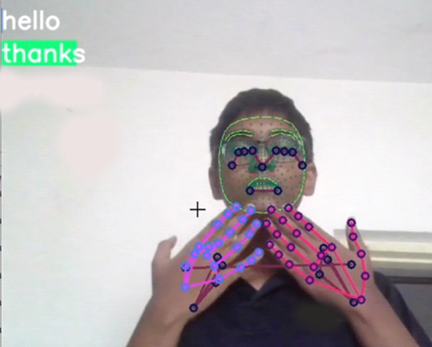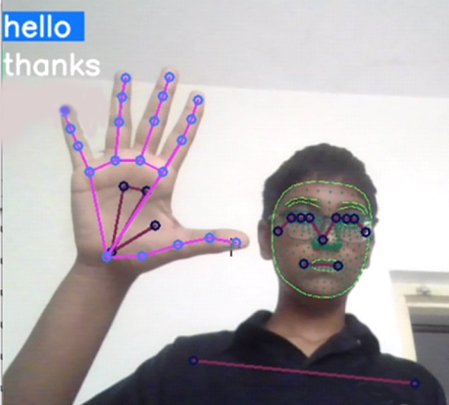

1. **Conclusion:**

In this report, a functional real time vision based American sign language  
recognition for D&M people have been developed for asl alphabets. We  
achieved final accuracy of 90.5% on our dataset. We are able to detect almost all the symbols provided that they are  
shown properly, there is no noise in the background and lighting is adequate.

**8.Reference:**

**Continuous Integration**

* <https://www.youtube.com/watch?v=yr23WyC2pr0>.
* <https://aclanthology.org/W16-6319.pdf>
* <https://www.cse.scu.edu/~mwang2/projects/NLP_English2IndianSignLanuguage_18w.pdf>
* <https://youtu.be/S1Ow2D_DL0s>

**Unit testing**

* <https://cocalc.com/doc/jupyter-notebook.html>
* <https://opencv.org/>